“THEIR SPIRITS LIVE WITHIN US”
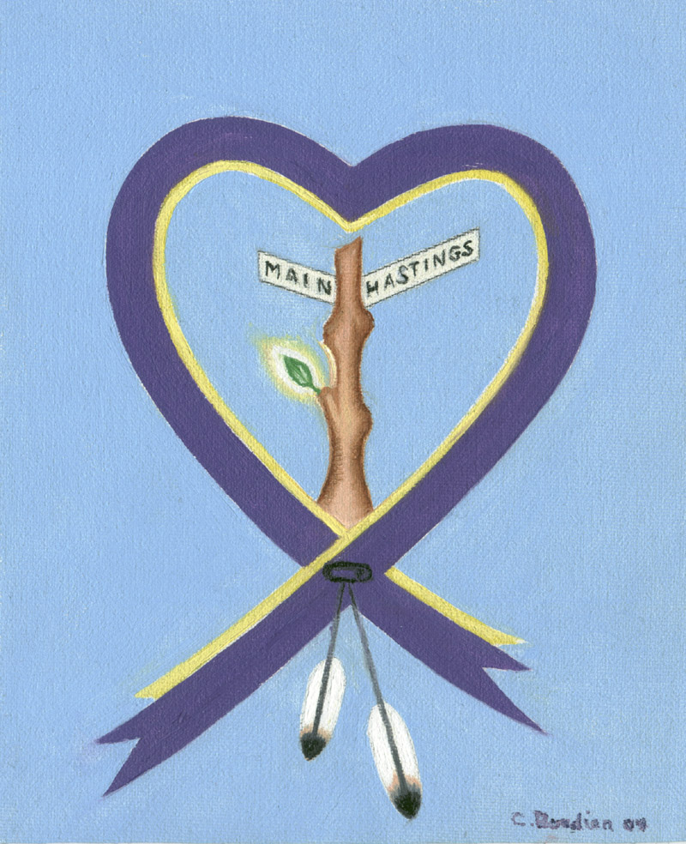

35TH ANNUAL WOMEN’S MEMORIAL MARCH
LED BY INDIGENOUS WOMEN TO HONOUR THE MMIWG2S+
SATURDAY, FEBRUARY 14, 2026

10 AM: GATHER AT MAIN AND HASTINGS
For family and community remembrance. Link to stream: https://tinyurl.com/nhhpuv4j

12 – 4 PM: MARCH BEGINS AT MAIN & HASTINGS
With stops to commemorate where women were last seen or found

4-5 PM: FEAST AT JAPANESE LANGUAGE HALL
(487 Alexander Street)

Facebook: https://bit.ly/40FITsK

The Memorial March is an opportunity to come together to grieve the loss of our beloved sisters and relatives in the Downtown Eastside. We dedicate ourselves to justice because Indigenous women, girls, two spirit & trans people still face physical, mental, emotional, and spiritual violence on a daily basis. All welcome.
This event takes place on the unceded territories of the xʷməθkʷəy̓əm (Musqueam), Sḵwx̱wú7mesh (Squamish), səl̓ílwətaʔ (Tsleil-Waututh) peoples.
Artwork courtesy of Christiane Bordier.

