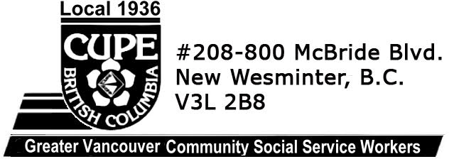
April 27, 2020
Dear PHS 1004 and 1936 members,

It is with great sadness that we acknowledge a member of our family has passed on.

CUPE 1004 and 1936 wish to honour the life of brother David Apsey today and in the future.

Dave was one of the founding members of the harm reduction movement and a foundational influence on the delivery of true community-based health services in the Downtown Eastside. He loved his neighborhood and he loved his neighbours, who he worked tirelessly to protect.

Dave also deeply cared for the comrades he worked with on the frontlines, the so-called "peer" workers who are the true first responders to multiple health emergencies. Brother Apsey spearheaded the organizing drive of community workers to achieve solidarity in making sure their life saving work was respected.

Together, CUPE 1936 and 1004 honours Dave Apsey's commitment to justice, fairness, and life. Rest in power.

In solidarity,

Sheryl Burns
President, CUPE Local 1936
Andrew Ledger,
President, CUPE Local 1004

